# CS 255 System Design Document

## UML Diagrams

### UML Use Case Diagram

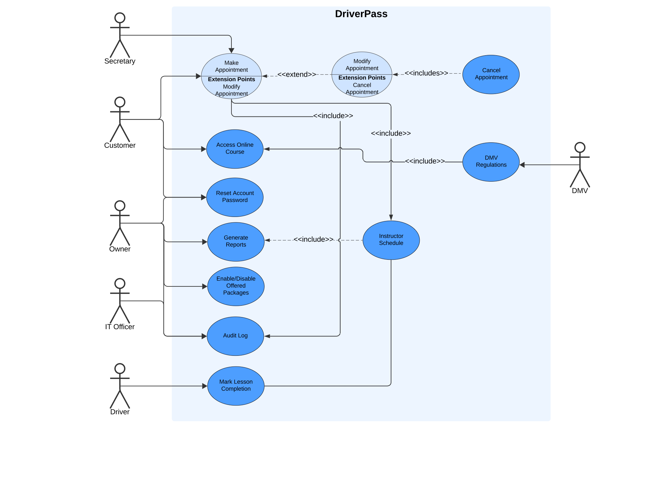

### UML Activity Diagrams

*Use Case #1: Customer wants to make an appointment with a Driver for a driving lesson.*

*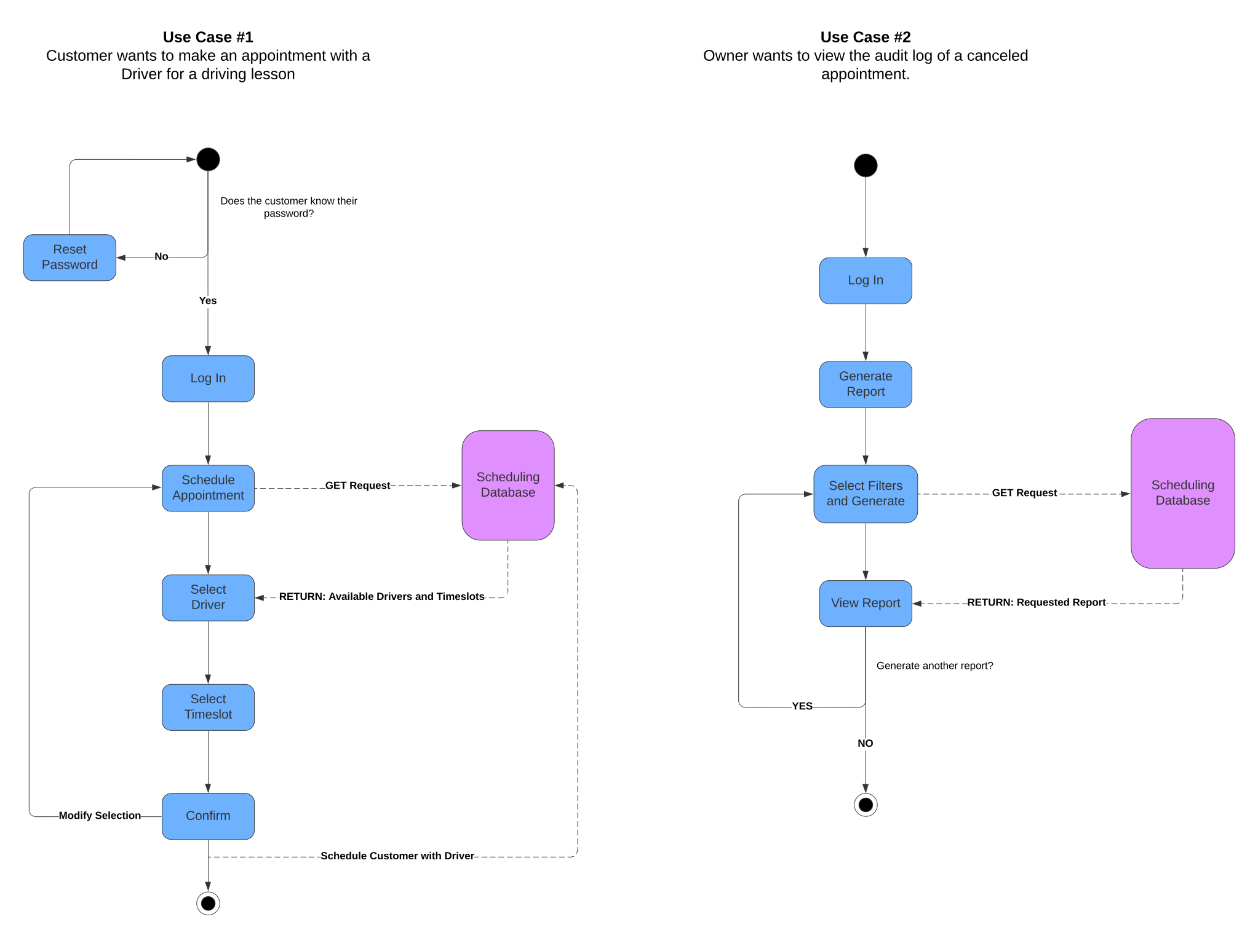Use Case #2: Owner wants to view the audit log of a canceled appointment.*

### UML Sequence Diagram

*Use Case #1: Customer wants to make an appointment with a Driver for a driving lesson.*

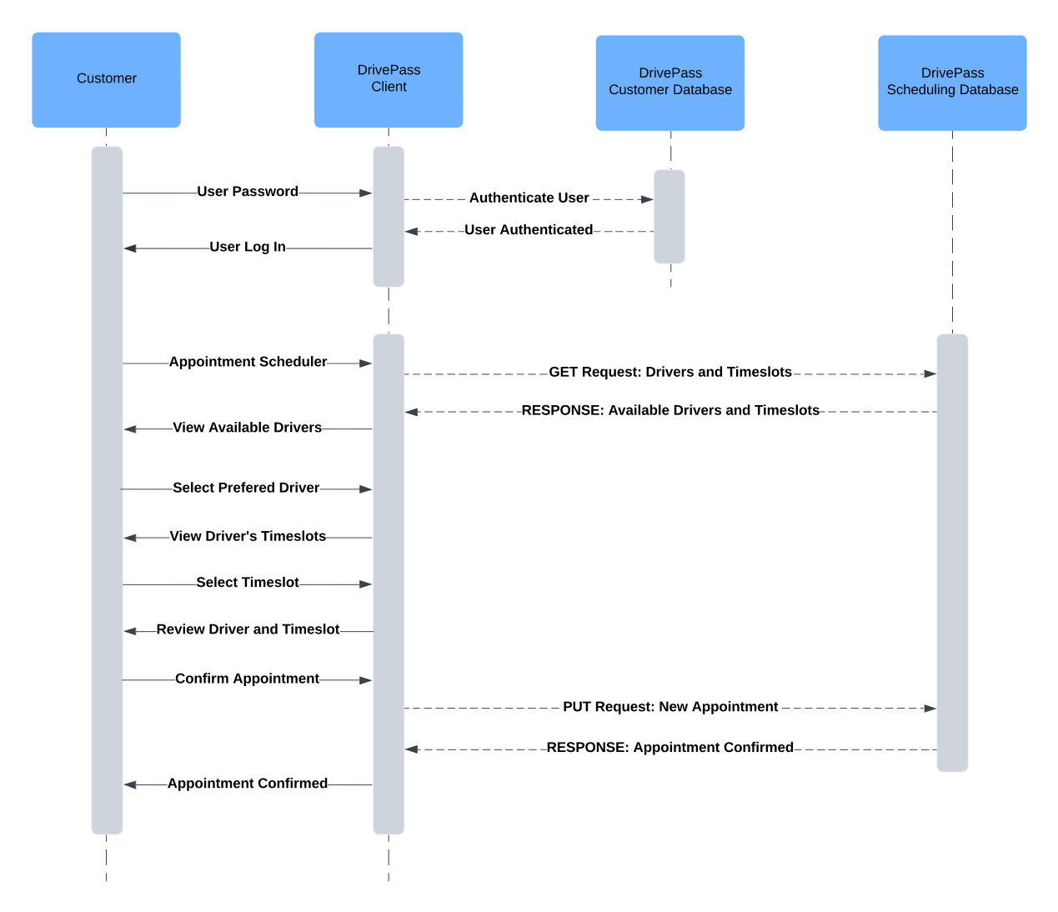

### UML Class Diagram

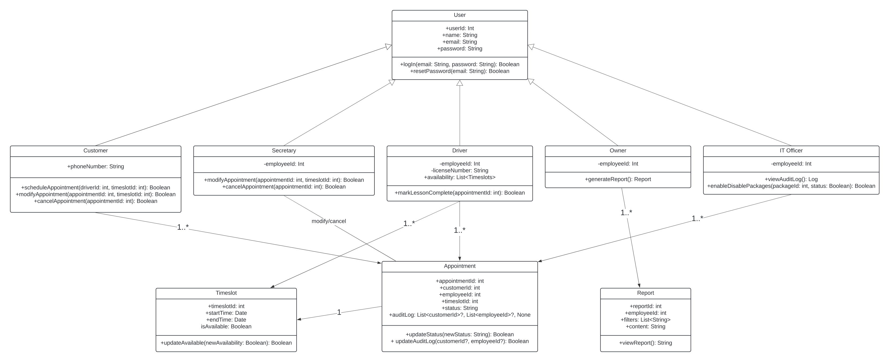

## Technical Requirements

1. Hardware Requirements
   1. Client Devices
      1. Windows, Mac, and Linux PCs capable of running a modern web browser
      2. iOS or Android mobile device that can run a modern web browser
   2. Server Infrastructure
      1. Cloud database for managing user data and appointments (e.g. MySQL)
      2. Cloud based web server for hosting the DriverPass front-end
   3. Network Infrastructure
      1. Cloud first design to minimize downtime
      2. High-speed internet installed on location for employees and customers to access the DriverPass systems
2. Software Requirements
   1. Backend Development
      1. Python or Java for developing the backend logic of DriverPass’ system
   2. Frontend Development
      1. HTML and CSS for the user interface
      2. JavaScript for handling user interactions and displaying data from the backend
   3. Database Management
      1. MySQL or MongoDB database for storing user information and the scheduling database for the drivers
      2. Database web client for easier access and maintenance for developers and the IT Officer
   4. API Integrations
      1. Integrate DMV APIs for rules and regulation updates
   5. Security
      1. Authentication
         1. Multi-Factor Authentication as an additional security measure for users, but a required security measure for employees
      2. Encryption
         1. All requests from the client to any database should use HTTPS to secure data in transit.